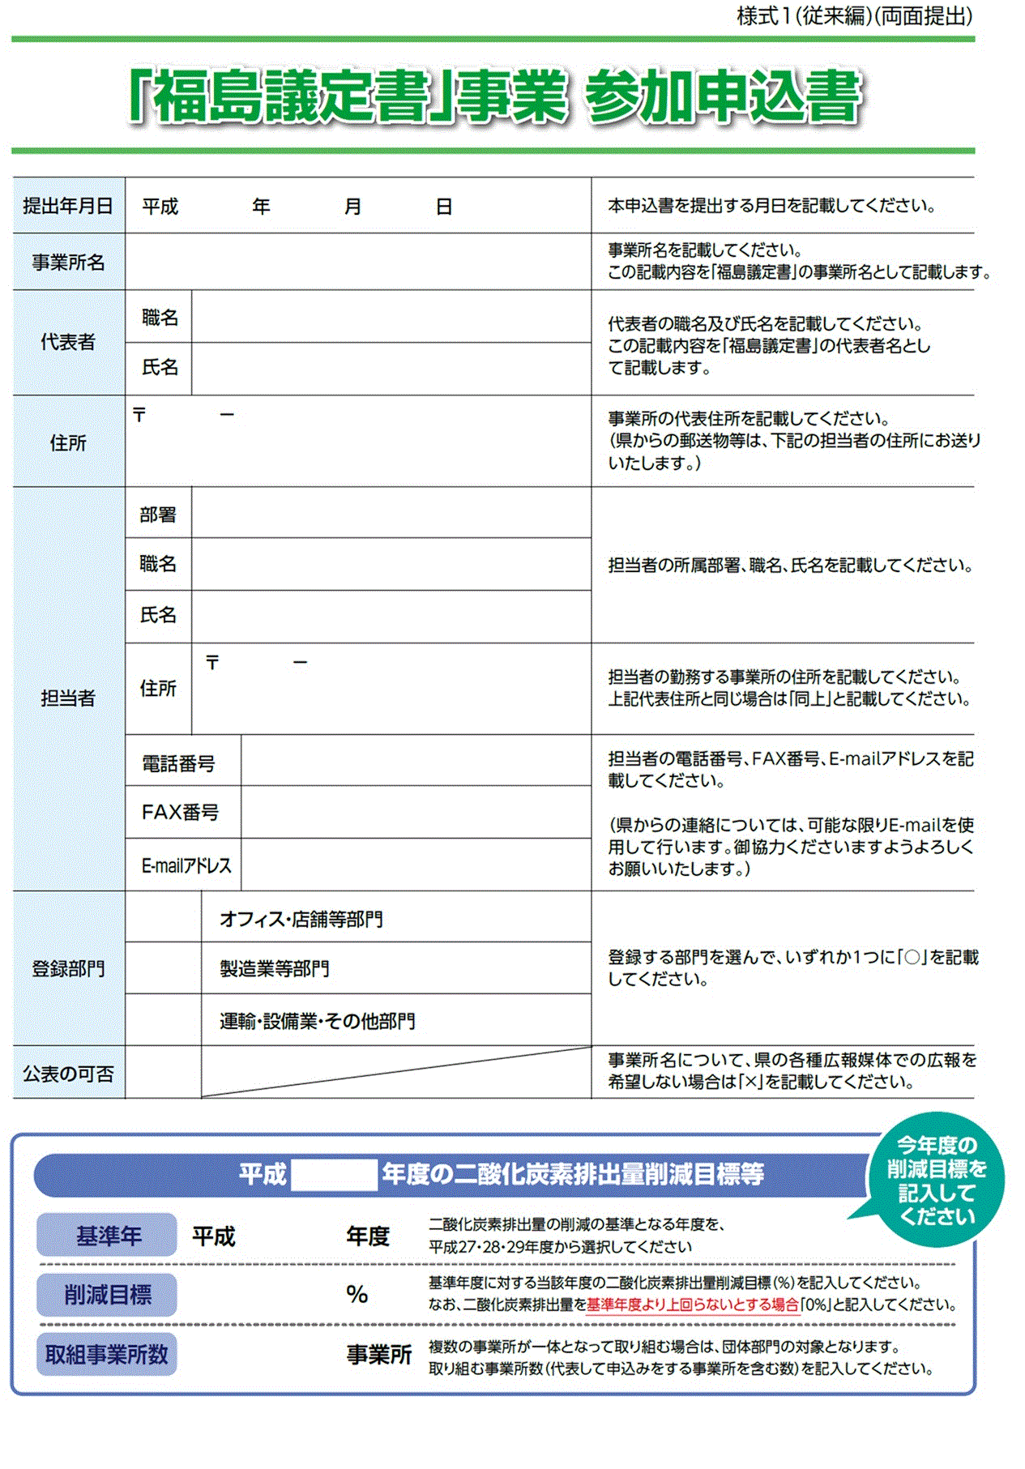

|  |  |
| --- | --- |
| 〒　　　－ | 市町村 |
|  | |

|  |  |
| --- | --- |
| 〒　　　－ | 市町村 |
|  | |



  
  
  

  
  
  